Step 1: select the instance and clik on connect

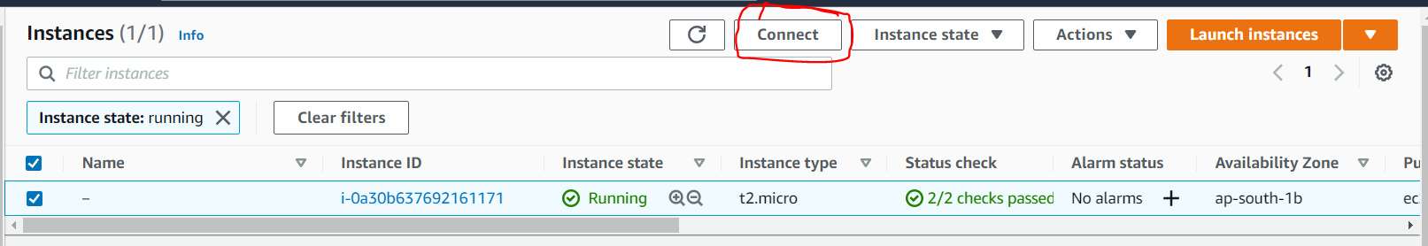

Step 2:

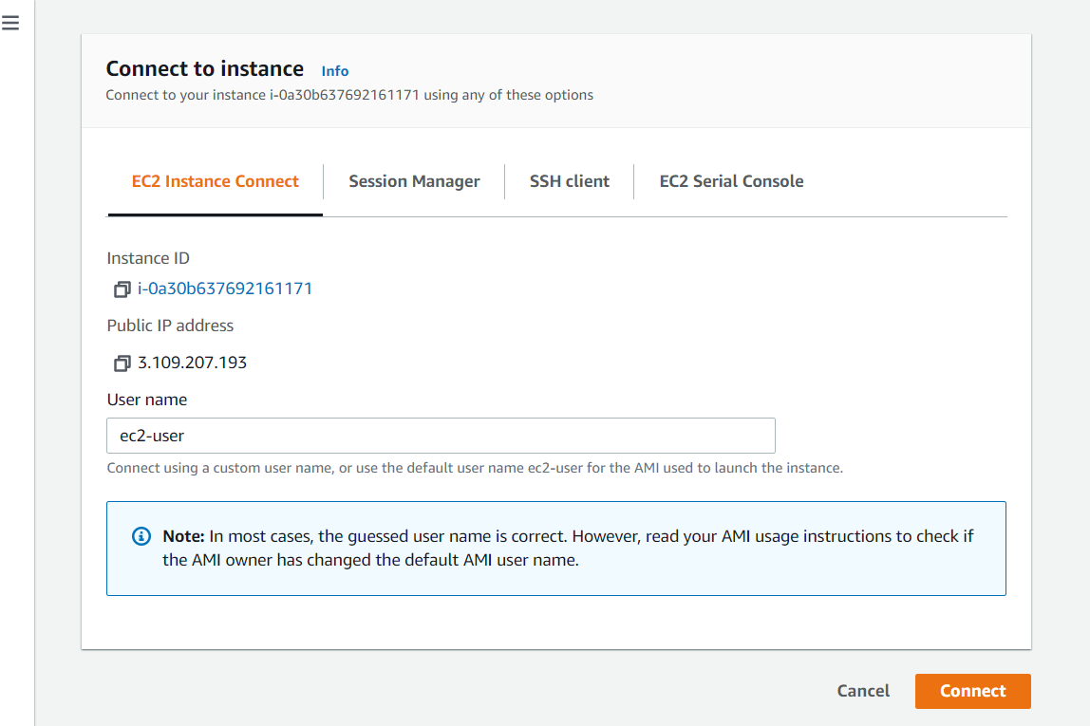

Click on connect

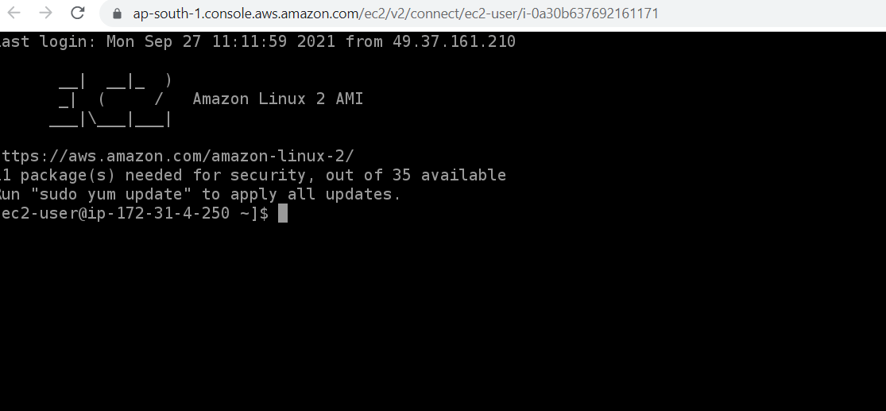

You are connected to the instance